भारत मौसम विज्ञान विभाग |  | India Meteorological Department
Saturday 16th May 2026 (26th Vaisakha 1948 Saka)
Summary of observations recorded at 0830 hours IST: The Southwest Monsoon is likely to set in over Kerala on 26th May with a model error of ± 4 days. Southwest monsoon has advanced into some parts of southeast Arabian Sea, southwest and southeast Bay of Bengal, many parts of Andaman Sea, entire Nicobar Islands and some parts of Andaman Islands including Sri Vijaya Puram today, the 16th May 2026. The Northern Limit of Monsoon passes through 5°N/75°E, 6°N/79°E, 8°N/85°E, 10.5°N/90°E, 13.5°N/95°E, and 15.5°N/98°E. During past 2 days (a) there has been widespread rainfall activity over Nicobar Islands and adjoining areas of Andaman Islands (b) the strength of westerlies over the region has increased and is around 35 kmph gusting to 45 kmph (c) the strength of westerlies over the region extended upto 4.5 km above mean sea level. (d) the Outgoing Longwave Radiation (OLR) over the region is less than 200 W/m2 indicating persistent convective cloud mass over the region. Thus, all the criteria are satisfied for advance of southwest monsoon over the region. Conditions are favourable for further advance of southwest monsoon into some more parts of southeast Arabian Sea, southwest and southeast Bay of Bengal, remaining parts of Andaman Islands and Andaman Sea, and some parts of eastcentral Bay of Bengal during next 3-4 days. The well-marked low-pressure area over southwest & adjoining westcentral Bay of Bengal lay as a low-pressure area over the same region at 0830 hrs IST of today, the 16th May 2026. The associated cyclonic circulation extended upto 4.5 km above m. s. l. tilting southwestwards with height. An upper air cyclonic circulation lay over north coastal Tamil Nadu & neighbourhood at 0.9 km above m. s. l. at 0530 hrs IST of today morning. It merged with the low-pressure area over southwest & adjoining westcentral Bay of Bengal. The Western Disturbance as a trough in middle tropospheric westerlies seen as a cyclonic circulation over Jammu adjoining north Pakistan at 3.1 km above m. s. l. persisted with a trough aloft in middle tropospheric westerlies with its axis at 5.8 km above m. s. l. ran roughly along Long. 70°E to the north of Lat. 33°N. An upper air cyclonic circulation lay over south Rajasthan & neighbourhood at 3.1 km above m. s. l. An upper air cyclonic circulation lay over east Rajasthan & neighbourhood at 0.9 km above m. s. l. An upper air cyclonic circulation lay over central Uttar Pradesh & neighbourhood and extended upto 1.5 km above m. s. l. An upper air cyclonic circulation lay over northwest Uttar Pradesh & adjoining Uttarakhand at 0.9 km above m. s. l. The upper air cyclonic circulation over East Madhya Pradesh & neighbourhood lay over northeast Vidarbha & neighbourhood at 0.9 km above m. s. l. at 0530 hrs IST of today morning. It persisted over the same region and seen upto 1.5 km above m. s. l. The east-west trough ran from north Bihar to south Assam across North Gangetic West Bengal at 0.9 km above m. s. l. The trough from the upper air cyclonic circulation over East Madhya Pradesh to North Interior Karnataka ran from the upper air cyclonic circulation over northeast Vidarbha & neighbourhood to Coastal Karnataka across Telangana and Interior Karnataka at 0.9 km above m. s. l. at 0530 hrs IST of today morning. It then persisted over the same region.
Maximum Temperature Departures (as on 15-05-2026): markedly above normal (> 5.1°C) at many places over Haryana-Chandigarh-Delhi and Jammu-Kashmir-Ladakh-Gilgit-Baltistan-Muzaffarabad; at few places over West Madhya Pradesh and Vidarbha; at isolated places over Punjab, Himachal Pradesh, West Rajasthan, East Rajasthan, East Madhya Pradesh and Coastal Andhra Pradesh & Yanam. appreciably above normal (3.1°C to 5.0°C) at few places over West Uttar Pradesh, Gujarat Region and Marathwada; at isolated places over Sub Himalayan West Bengal & Sikkim, Gangetic West Bengal, Odisha, Bihar, East Uttar Pradesh, Uttarakhand, Saurashtra & Kutch, Konkan & Goa and Telangana. above normal (1.6°C to 3.0°C) at few places over Madhya Maharashtra and Rayalaseema; at isolated places over Nagaland, Manipur, Mizoram & Tripura and Chhattisgarh. near normal (-1.5°C to 1.5°C) at many places over Jharkhand, North Interior Karnataka and Lakshadweep; at most places over Arunachal Pradesh, Assam & Meghalaya and Coastal Karnataka; at few places over Andaman & Nicobar Islands, South Interior Karnataka and Kerala & Mahe; at isolated places over Tamil Nadu, Puducherry & Karaikal. The highest maximum temperature of 45.2°C was reported at Banda (Uttar Pradesh), and Phalodi-Obs (Rajasthan).
Hailstorm reported at isolated places over Jammu-Kashmir, Uttarakhand and East Madhya Pradesh.
Heat wave conditions prevailed in isolated pockets over West Madhya Pradesh, Vidarbha and Saurashtra & Kutch.
Preliminary Earthquake Report: An earthquake shock of Super Moderate intensity at its origin with epicenter at Lat. 38.882° North and Long. 142.047°East of North Pacific Ocean about 6458 kms away from Pune, was recorded by the seismographs in the meteorological Office Pune at 17 Hrs. 01 Min. 46 Secs. IST on 16-05-2026 having its magnitude 6.5 on the Richter scale.
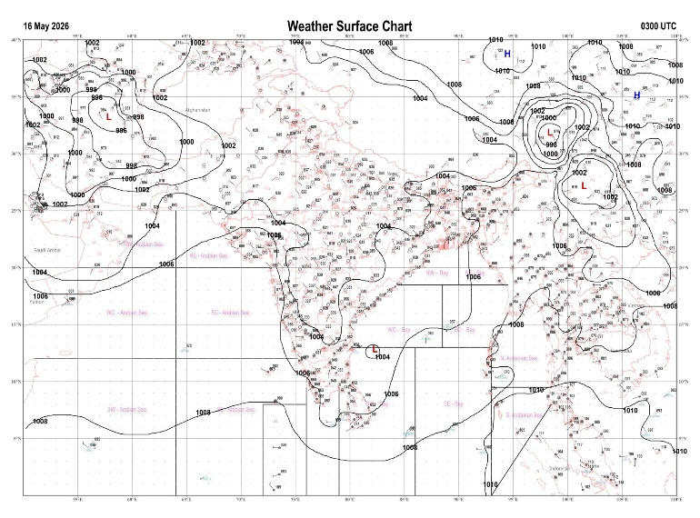 | 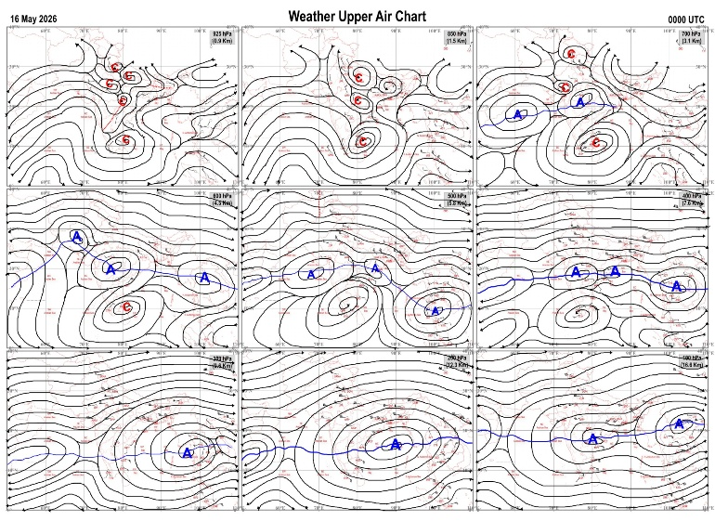
Fig.1. Analysed surface chart based on 03z observation | Fig.2. Analysed upper air chart based on 00z observation
Dr. S.D.Sanap
Scientist ‘D’
CR & S Office, Pune  Issued at 1245 hrs. IST |  | Weather Forecasting Division  CR&S, Pune

Indian regions | Realised rainfall (chief amount in cm during past 24 hrs):
East | most places: Sub-Himalayan West Bengal & Sikkim+++  many places: Arunachal Pradesh, Assam & Meghalaya+++, Nagaland-Manipur-Mizoram-Tripura and Gangetic West Bengal  isolated places: Odisha, Jharkhand and Bihar  Oodlabari tea estate 18.2, Karimganj 17.1, B p ghat 15.1, Jhallong 14.4, Silchar 7.5, Gangtok 7.4, Suri PTO 6.4, Chottabekra 6.0, Kailashahar AP 5.8, Kailashahar AWS 5.6, Suri (CWC) 4.9, Hetampur 4.2, Nawadih 3.9, Daparijo & Khalari 3.7 each, Daporizo AWS 3.5, Jamshedpur AP 2.4, Tuting 1.9, Bahadurganj 1.8, Thakurganj 1.5, Turekela 1.1, Boden 0.7, Forbesganj 0.5.
North | a few places: Uttarakhand  isolated places: Himachal Pradesh and Jammu-Kashmir and Ladakh  dry weather: Uttar Pradesh, Haryana, Punjab and Rajasthan  Dhanaulti 3.8, Pahalgam AWS 2.3, Rudraprayag 2.0, Tehri & Nowgam 1.6 each, Sarahan 1.5, Pahalgam 1.4, Sangla 0.4.
Central | isolated places: west Madhya Pradesh◆, east Madhya Pradesh and Chhattisgarh  dry weather: Vidarbha  Gundardehi 3.5, Pendra road 3.2, Shahpura 2.9, Raipur 2.7, Dindori-aws 1.8, Lahar & Mihona 0.2 each, Jabalpur-aws 0.1.
Peninsula | many places: Kerala  isolated places: Telangana◆, Rayalaseema, Tamil Nadu+, north interior Karnataka◆ and south interior Karnataka  dry weather: Gujarat State, Konkan & Goa, Madhya Maharashtra, Marathwada, coastal Andhra Pradesh and coastal Karnataka  Puducherry 7.5, Choondy AWS 5.5, Newchennai township AWS 5.1, Paripalli AWS 4.7, Mysuru PTO 4.5, Singanamala & Oothu 3.8 each, Begur 3.2, Sargur 2.9, Kannur 2.5, Dornipadu 0.8, Gangavathi ARG 0.2, Shadnagar (ARG) 0.1.
Islands | most places: Andaman & Nicobar  a few places: Lakshadweep  Iaf carnicobar 4.9, Minicoy 1.9, Maya bandar 1.4, Nancowry 1.2.
Table-2 Forecast / warnings (distribution of rain / thundershowers) for 7 days (valid from time of origin upto 0830 hrs IST of next day)
Sr N. |  | Sub-division Name | Day 1 | Day 2 | Day 3 | Day 4 | Day 5 | Day 6 | Day 7 | Sr. No. | Sub-division Name | Day 1 | Day 2 | Day 3 | Day 4 | Day 5 | Day 6 | Day 7
 |  |  | 16 May | 17 May | 18 May | 19 May | 20 May | 21 May | 22 May |  |  | 16 May | 17 May | 18 May | 19 May | 20 May | 21 May | 22 May
 | 1 | Andaman Nicobar Islands | W ++  | W ++  | W  | W  | W  | W  | W  | 19 | west Madhya Pradesh | D + | D + | D + | D + | D + | D | D
 | 2 | Arunachal Pradesh | F +  | F +  | S  | S  | F + | F + | F + | 20 | east Madhya Pradesh | I  + | D + | D + | D + | D + | D + | D +
 | 3 | Assam-Meghalaya | W +  | F+ | F + | S +  | F  | F + | W + | 21 | Gujarat region | D | D | D | D | D | D | D
 | 4 | Nagaland-Manipur-Mizoram-Tripura | F +  | F  | S  | S  | S  | F + | F + | 22 | Saurashtra and Kutch | D | D | D | D | D | D | D
 | 5 | Sub Him West Bengal/Sikkim | W +  | W ++  | F +  | S | F  | S | F | 23 | Konkan and Goa | I  + | I  | I | I | I | I | I
 | 6 | Gangetic West Bengal | S  | S  | S  | I | I | I | S | 24 | Madhya Maharashtra | I  | I  | I | D | D | D | D
 | 7 | Odisha | I  | I  | I  | I  | I  | I | I | 25 | Marathwada | D  | D  | D  | D | D | D | D
 | 8 | Jharkhand | I  | I  | S  | I  | S  | I | I | 26 | Vidarbha | D + | D + | D + | D + | D + | D + | D +
 | 9 | Bihar | S  | I  | I  | I  | S  | I | I | 27 | Chhattisgarh | D  | D  | D  | D | D + | D + | D +
 | 10 | east Uttar Pradesh | D + | D + | D + | D + | I + | I + | I+ | 28 | Coastal Andhra Pradesh and Yanam | I  | I  | I  | I  | I  | I | I
 | 11 | west Uttar Pradesh | D + | D + | D + | D + | D + | D + | D+ | 29 | Telangana | I  | I  | D | D | D | D | D
 | 12 | Uttarakhand | I  | I  | D | D | I | I | I | 30 | Rayalaseema | S  | I  | I  | I  | I  | I | I
 | 13 | Haryana,Chandigarh and Delhi | D | D | D + | D + | D + | D+ | D+ | 31 | Tamil Nadu, Puducherry and Karaikal | I +  | S +  | S+  | S+ | I | S | S
 | 14 | Punjab | D | D | D + | D + | D + | D+ | D+ | 32 | Coastal Karnataka | I  | I | I | I | I | I | I
 | 15 | Himachal Pradesh | I  | I  | D | D | D | D | I | 33 | North interior Karnataka | I  | I  | I  | D | D | D | D
 | 16 | Jammu-Kashmir and Ladakh | F  | D | D | F  | F  | I | I | 34 | South interior Karnataka | S +  | S +  | S +  | I +  | I  | I | I
 | 17 | west Rajasthan | D + | D + | D + | D + | D + | D+ | D+ | 35 | Kerala and Mahe | W+ | W+ | W+ | F  | F  | F | F
 | 18 | east Rajasthan | I  | D + | D + | D + | D + | D+ | D+ | 36 | Lakshadweep | W+ | W+ | F | F | F | F | F
Legends: D = Dry I =isolated S = Scattered F = Fairly widespread W = Widespread #= heavy to very heavy rain at a few places with extremely heavy rain at isolated places+++= heavy rain at a few places with very heavy rain at isoIated places++= heavy to very heavy rainfall @=isolated exceptionally heavy rainfall+ = heavy rain ●/*= rain or snow ♦ = very light rain ≡=fog = thunderstorm with lightning =Squall / Gusty / gale / strong wind -=cold wave/cold day + = heat wave/warm night/hot and humid weather =Duststorm =ground frost = Hail.
Fig. 4: Districtwise warnings for five days for Maharashtra State
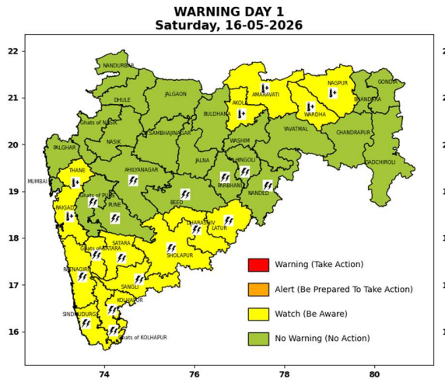 | 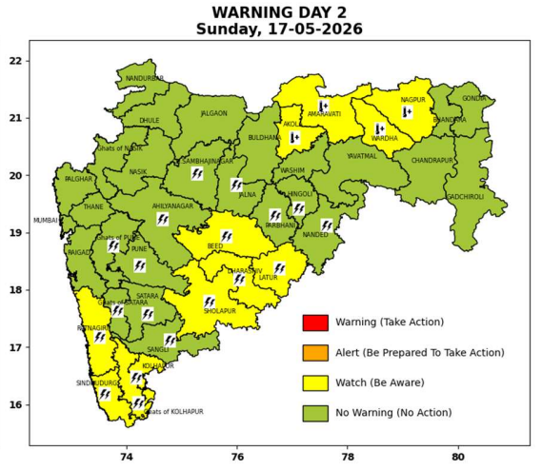 | 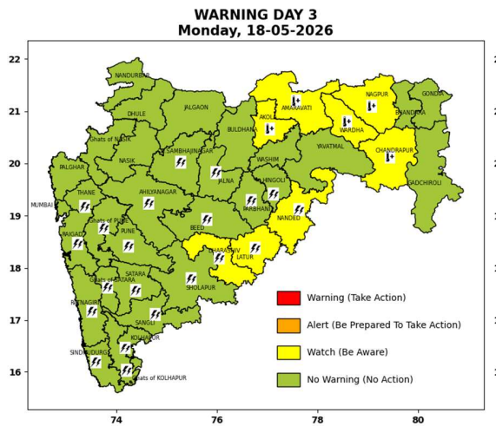 | 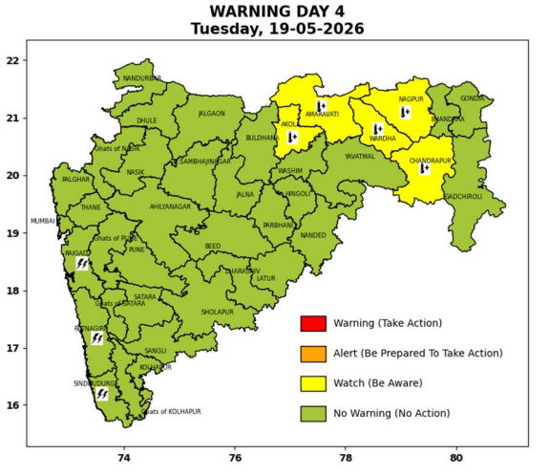 | 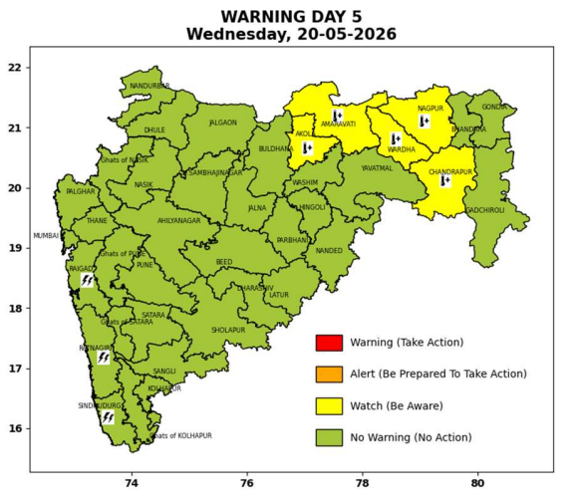

Pune, Lohegaon and Pashan observations at 0830 hrs. IST of Today
 | Temperature (°C) |  |  |  |  | Humidity (%) |  |  |  | Rainfall (mm)
 | Max.  past  24 hrs | Dep.  from  normal | Min.  past  24 hrs. | Dep.  from  normal | Dry  Bulb | At 0830 hrs. IST | Dep.  From  normal | At 1730  hrs. IST of y’day | Dep.  from  normal | Past  24 hrs. | Since  1st March | Dep.  from  normal
PNE | 36.2 | -1.3 | 23.7 | 0.3 | 27.2 | 67 | 7 | 35 | -1 | 0.0 | 92.8 | 68.8
PSN | 36.2 | - | - | - | - | 41 | - | - | - | - | - | -
LHG | 38.0 | 0.0 | 25.6 | 4.6 | 28.2 | 68 | 8 | 35 | 3 | 0.0 | 91.4 | 61.9

 |  |  |  |  |  |  | Local (Pune and neighbourhood) forecast
Max./Min. Temperature (°C) |  |  |  |  |  |  |  |  | Weather
Date | Pune | Pashan | Lohegaon | Chinchwad | Lavale | Magarpatta | NDA | Koregoan park
16/05/26 | 39 / 23.7* | 38 / - | 41 / 25.6* | 39 / 24.6* | 38 / 20.7* | 40 / 25.5* | 37 / 20.6* | 40 / 25.6* | Mainly clear sky becoming partly cloudy sky towards afternoon or evening.
17/05/26 | 38 / 24 | 38 / 24 | 40 / 25 | 38 / 24 | 37 / 21 | 39 / 25 | 37 / 21 | 38 / 25 | Mainly clear sky becoming partly cloudy sky towards afternoon or evening.
18/05/26 | 37 / 24 | 37 / 24 | 39 / 25 | 37 / 24 | 36 / 21 | 38 / 25 | 36 / 21 | 37 / 25 | Mainly clear sky becoming partly cloudy sky towards afternoon or evening.
19/05/26 | 37 / 23 | 37 / 23 | 39 / 24 | 37 / 23 | 36 / 20 | 38 / 24 | 36 / 20 | 37 / 24 | Mainly clear sky becoming partly cloudy sky towards afternoon or evening.
20/05/26 | 36 / 23 | 36 / 23 | 38 / 24 | 36 / 23 | 35 / 20 | 37 / 24 | 35 / 20 | 36 / 24 | Mainly clear sky becoming partly cloudy sky towards afternoon or evening.
21/05/26 | 36 / 22 | 36 / 22 | 38 / 23 | 36 / 22 | 35 / 19 | 37 / 23 | 35 / 19 | 36 / 23 | Mainly clear sky becoming partly cloudy sky towards afternoon or evening.
22/05/26 | 36 / 22 | 36 / 22 | 38 / 23 | 36 / 22 | 35 / 19 | 37 / 23 | 35 / 19 | 36 / 23 | Mainly clear sky becoming partly cloudy sky towards afternoon or evening.
Rainfall Distribution |  |  |  |  | Rainfall Categories | Rainfall (mm) | Cloud condition |  | Rainfall Intensity | Range
Widespread (W) | 76-100% |  |  |  | Very Light rain | Trace to 2.4 mm | Mainly clear sky | 1-2 oktas | Light Spell | 1 cm/hr
 |  |  |  |  | Light rain | 2.5 to 15.5 mm | Partly cloudy sky | 3-4 oktas | Moderate Spell | 1-2 cm/hr
Fairly Widespread (FW) | 51 – 75% |  |  |  | Moderate rain | 15.6 to 64.4 mm | Generally cloudy sky | 5-7 oktas | Intense Spell | 2-3 cm/hr
Scattered (S) | 26 – 50% |  |  |  | Heavy rain | 64.5 to 115.5 mm | Overcast | 8 oktas | Very Intense Spell | 3-5 cm/hr
Isolated (I) | 1 – 25% |  |  |  | Very heavy rain | 115.6 to 204.4 mm |  |  | Extremely Intense Spell | 5-10 cm/hr
Dry (D) | No Rain |  |  |  | Extremely heavy rain | ≥ 204.5 mm |  |  | Cloudburst | > 10 cm/hr
Probability Terms in %: |  |  |  |  | Heavy snow | 6.5 to 11.5 cms water equivalent of rain
unlikely | < 25 |  |  |  | Very heavy snow | 11.6 to 20.4 cms water equivalent of rain
likely | between 25 50
very likely | between 51 75
most likely | >75
* = realized temperatu
Mumbai (Colaba) |  |  |  | Nagpur (AP)
Date 2026 | T max °C | T min °C | Weather | T max °C | T min °C | Weather
16/05/26 | 35 | 28 | Clear sky. | 45 | 26 | Heat Wave.
17/05/26 | 34 | 28 | Clear sky. | 45 | 26 | Heat Wave.
18/05/26 | 34 | 28 | Clear sky. | 45 | 26 | Heat Wave.
19/05/26 | 34 | 28 | Clear sky. | 45 | 26 | Heat Wave.
20/05/26 | 34 | 28 | Clear sky. | 46 | 26 | Heat Wave.
21/05/26 | 34 | 28 | Clear sky. | 45 | 26 | Heat Wave.
22/05/26 | 34 | 28 | Clear sky. | 45 | 26 | Heat Wave.

